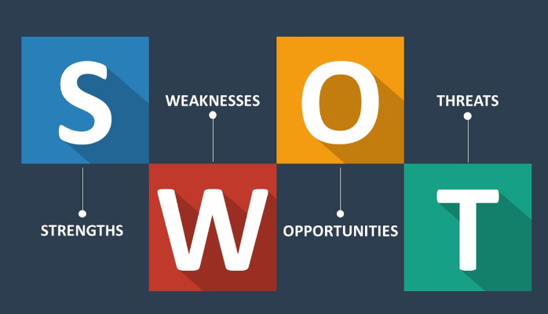

Use the following questions to support you in conducting a self SWOT analysis:

**Strengths (don’t be modest):**

* How do your education, skills, talents, certifications, and connections / networks set you apart from your peers?
* What would your boss or coworkers say are your strengths?
* What resources do you have at your disposal?
* What contributed the most to your past victories?
* What values or ethics do you have that your peers often lack?
* What achievements are you most proud of?

**Weaknesses (be honest):**

* Where are your education, training, or skills lacking? What’s missing and needs improvement?
* What would your boss or coworkers say are your weaknesses or areas of improvement?
* What are your negative work habits and personality traits?  
   What do you avoid because you lack confidence?

**Opportunities:**

* Which opportunities are you not exploiting at the moment?
* What trends are affecting your industry – the industry you belong to or wish to be in?
* In what areas is your industry growing?
* How could new technology help you advance?
* How could your connections and networks help you?

**Threats:**

* What obstacles do you currently face in your career and life?
* Who is your competition?
* Will new technology or certifications demands slow your progress in achieving your goals?
* How is your job or industry changing in ways that could affect your advancement?

S.W.O.T

|  |  |
| --- | --- |
| Strengths  1. Am a fast learner,  2. I know how to perfectly manage my time well, because i know what really matters is what I do in those hours.  3. I am trustworthy and contented.  4. I believe am confident.  5. They say books make you wise, I am wise.  6. I always make sure i work smart and give it all my best.  7. I believe in the power of the mind, what i feed my mind it's what it will concieve. | Weaknesses  1. My worst weakness is procrastination.    I will plan and execute my intended goals and make sure I work on them.  2. I feel like sometimes my words hurt people, i want to talk less. |
| Opportunities  1.I have the opportunity to study programming, life skills and entrepreneurship and all that I have dreamed of becoming.  2.I have free WIFi in which i can self-learn and achieve my goals.  3. I have mentors here and real people who have made it In life and i really look up to and consider my role models, You are one of them veronica. | Threats  I am my own competition, I strive to everyday to learn more and to be better than i was yesterday. |